Software Testing Assignment

**Module: - 1 [ Fundamental]**

**1: -What is SDLC?**

**SDLC** (Software Development Life Cycle) is a step-by-step process used to develop software.

**2: -What is software testing?**

Software Testing is a process used to identify the correctness, completeness, and quality of developed computer software.

**Testing Activities: -**

* Planning and Control
* Choosing test
* conditions Designing
* test cases Checking results
* Evaluating completion criteria
* Reporting on the testing process and system under test Finalizing or closure (e.g. after a test phase has been completed)
* Testing also includes reviewing of documents (including source code) and static analysis.

**3: -What is agile methodology?**

Agile means building software little by little, getting feedback quickly and making changes as needed instead of waiting until everything if finished.

**3: -What is SRS?**

(SRSisstand for Software Requirements Specification.)

* SRS is a document that clearly defines what the software should do, how it should behave and what features it must have.

**4: - What is OOPS?**

(OOPs is Object Oriented Programming System)

* OOPs is a programming approach where code is organised using objects, making it easier to manage, reuse and maintain.

**5: -Write Basic Concepts of oops?**

**1: -Class**

**2: -Object**

**3: -Encapsulation**

**4: -Abstraction**

**5: - Inheritance**

**6: - Polymorphism**

**6: -What is object?**

* An object is a real-world thing in programming that has properties (data) and actions (methods).
* **Object** = Something you can describe and use.

**7: - what is class?**

* A class is a template or blueprint used to create objects.
* If defines what an object will have and what is can do.

**8: - What is encapsulation?**

* Encapsulation is like a medicine capsule
* The outer cover hides the bitter medicine inside. You only use it, but don’t see how it’s made.

**9: - What is inheritance?**

* Inheritance means one class gets properties and method from another class. It helps to reuse code and build relationships between classes.

**10: - What is polymorphism?**

* Polymorphism means “many forms”.
* In oop, it allows one function or method to behave differently based on the object using it.

**11: -** **Draw Use case on online flight booking system**

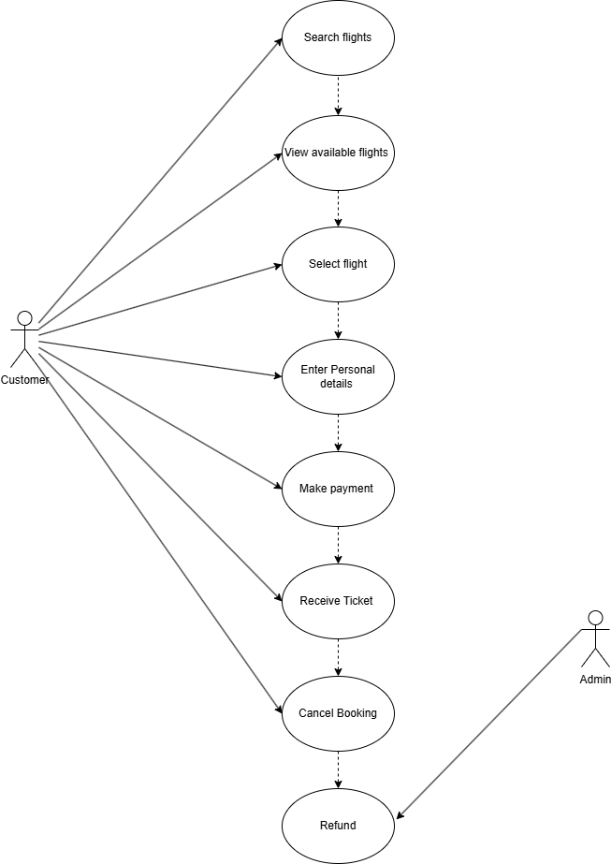

**12: - Draw Usecase on online bill payment system (Paytm)**

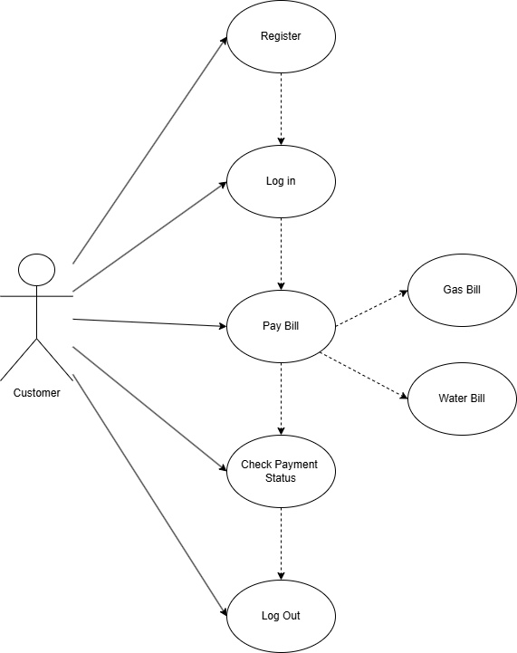

**13: -Draw Usecase on banking system for customers.**

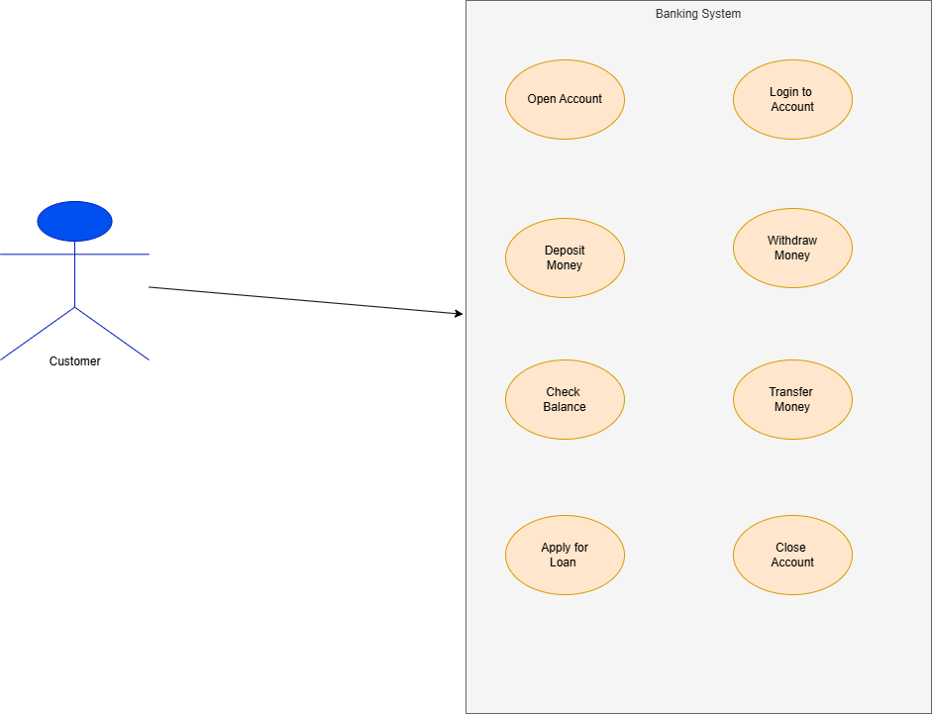

**14: - Draw Usecase on Broadcasting System.**

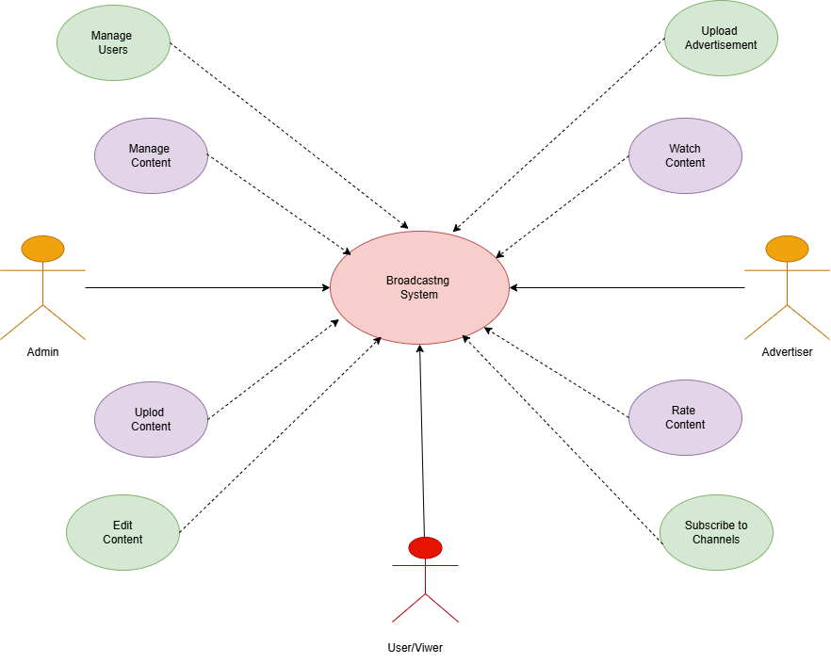

**15: - Write SDLC phases with basic introduction.**

1. **Requirement collection** - Understand what the software needs to do.

(Note down all feature, rules and expectations)

1. **Analysis** – Study the requirement in details.

(Check if they are possible to build)

1. **Desing** – Plan how to software will work.

(Create diagram, architecture and layout)

1. **Implementation** – Developers build the software based on desing.

(May developer only a part at a time)

1. **Testing** – Check if everything works properly.

(Test the software for bugs and errors)

1. **Maintenance** – Fix bugs and make improvements after release.

(Fix bugs, update features and iteration)

**16: - Explain Phases of the waterfall model.**

1. **Requirement Collection** – Collect all the information about what the software should do.
2. **Analysis –** Study the requirements deeply.
3. **Desing -** Plan how the software will look and work.
4. **Implementation –** Start writing the actual code based on the desing.
5. **Testing –** Check the software for bugs, error and missing feature.
6. **Maintenance –** After release support and update the software.

**17: -** **Write phases of spiral model.**

1. **Planning** – Determination of objective, alternatives and constraints.
2. **Risk Analysis** – Analysis of alternative and identification/resolution of risk.
3. **Engineering** – Development of the “next level” product.
4. **Customer Evolution** – Assessment of the results of engineering.

**18: - Write agile manifesto principles.**

1. **Customer satisfaction through early and continuous software delivery** – Customers are happier when they receive working software at regular intervals, rather than waiting extended periods of time between releases.
2. **Accommodate changing requirements throughout the development process** – The ability to avoid delays when a requirement or feature request changes.
3. **Frequent delivery of working software** – Scrum accommodates this principle since the team operates in software sprints or iterations that ensure regular delivery of working software.
4. **Agile processes to support a consistent development pace** – Teams establish a repeatable and maintainable speed at which they can deliver working software, and they repeat it with each release**.**
5. **Regular reflections on how to become more effective** – Self-improvement, process improvement, advancing skills, and techniques help team members work more efficiently.

**19: -** **Explain working methodology of agile model and also write pros and cons.**

* **Methodology of agile -** Agile SDLC model is a combination of iterative and incremental process models with focus on process adaptability and customer satisfaction by rapid delivery of working software product.
* Agile Methods break the product into small incremental builds. These builds are provided in iterations.
* At the end of the iteration a working product is displayed to the customer and important stakeholders.
* **Pros** – Is a very realistic approach to software development Promotes teamwork and cross training.
* Is a very realistic approach to software development Promotes teamwork and cross training.
* planned context.
* Little or no planning required Easy to manage
* Gives flexibility to developers
* **Cons** - Not suitable for handling complex dependencies.
* More risk of sustainability, maintainability and extensibility.
* An overall plan, an agile leader and agile PM practice is a must without which it will not work.

**20: -Draw use case on OTT Platform.**

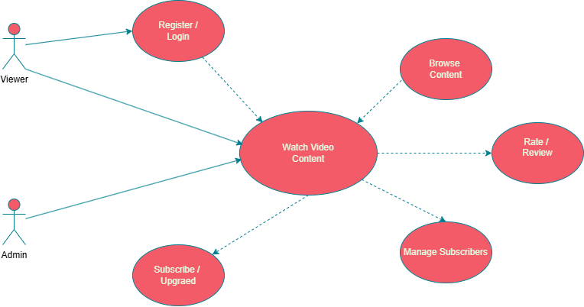

**21: - Draw use case on E-commerce application.**

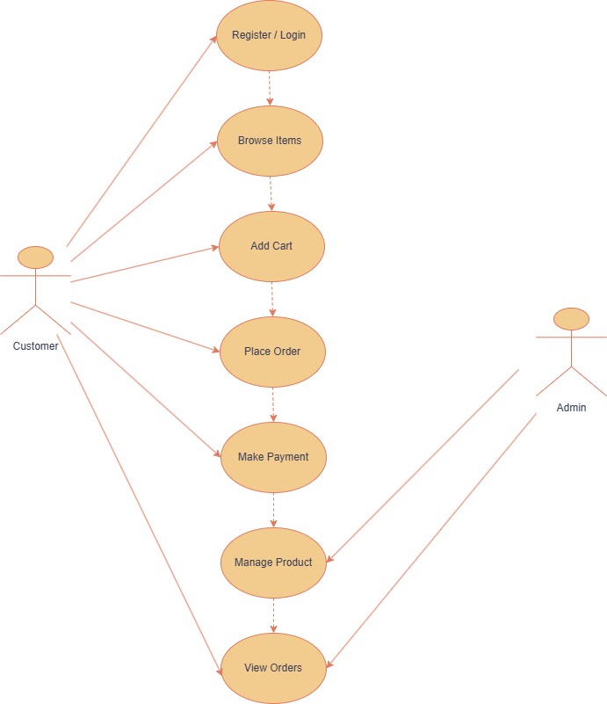

**22: - Draw use case on Online shopping product using payment gateway.**

